**1. INTRODUCTION:**

**1.1 Algae**

Algae, a diverse collection of photosynthetic organisms, display a wide range of shapes, sizes, and ecological niches. They are categorized within either the Protista kingdom, depending on the specific classification scheme (Finlay, et al.,2004). Algae encompass a vast spectrum of species, ranging from minute single-celled forms to expansive multicellular seaweeds. Algae are divided into two types based on their size: microalgae and macroalgae. Macroalgae are enormous water photosynthetic plants that can be seen without a microscope and are classified as green (*Chlorophyta*), red (*Rhodophyta*), and brown-kelps (*Phaeophyta*—related to *Chromista*). Microalgae are the smallest algae, often known as phytoplankton (Osundeko, et al., 2014]. They are usually unicellular or form tiny colonies. As primary producers, microalgae play an important role in aquatic ecosystems, constituting the foundation of marine and freshwater food chains. Diatoms, dinoflagellates, coccolithophores, and other tiny unicellular organisms are among them. Because of their tiny size, they may be carried by water currents and are an important component of global carbon and nutrient cycles (Siano, et al., 2012). Representative genera of microalgae include *Arthrospira*, *Chlorella*, *Dunaliella,* *Nostoc*, and *Aphanizomenon*. Cyanobacteria, a kind of prokaryotic microalgae, play an important role in the natural ecosystem, their classification often hinges on their photosynthetic pigments, including chlorophylls, xanthophylls, and carotenoids, which influence their coloration and light-capturing abilities. Prominent algae groups encompass cyanobacteria (blue-green algae), green algae, brown algae, red algae, and diatoms. While algae lack a unified ancestral source, their ecological roles as primary producers and their diverse contributions to ecosystems underscore their pivotal importance in the natural realm (Lembi, et al.,1988).

Algae have evolved to a broad range of habitats, from aquatic to terrestrial landscapes. Their extraordinary capacity to flourish in a variety of environments has allowed them to invade ecosystems all over the world. This flexibility derives from their unique biological and physiological features, which enable them to exploit certain niches and contribute to the functioning of ecosystems (Delwiche, et al., 2015).

* **Aquatic Environments**: Algae are most famous for their appearance in aquatic habitats. They are important primary producers in marine environments, contributing considerably to the formation of organic matter by photosynthesis. The foundation of marine food chains is phytoplankton, which is made up of many types of microalgae. Diatoms, dinoflagellates, and cyanobacteria are some of the most common algae found in these environments. Algae have a similar function as primary producers in freshwater bodies such as lakes, rivers, and ponds. They are frequently visible as green or brown films on the surface of bodies of water or as suspended particles. Algae in these conditions help to produce oxygen and cycle nutrients.
* **Terrestrial Environments**: While algae are commonly associated with water, they may also be found in terrestrial ecosystems, particularly in areas with persistent dampness. They may live on moist surfaces like tree trunks, rocks, and mud. Lichens, which are symbiotic relationships between fungus and algae or cyanobacteria, are an excellent example of terrestrial algae adaptability. These unusual creatures can live in a wide range of environments, from deserts to polar areas, and contribute to soil formation and nutrient cycling.
* **Symbiotic Relationships**: Algae create symbiotic relationships with a variety of creatures. Coral reefs, for example, rely on a symbiotic interaction between corals and dinoflagellates called zooxanthellae. Through photosynthesis, algae supply nutrients and oxygen to corals, while corals provide protection and habitat. This symbiotic relationship is important for the health and longevity of coral reef ecosystems (Rajak, et al., 2019)

**1.2 Microalgae**

Microalgae, recognized as microscopic algae, represent a diverse group of microscopic photosynthetic organisms existing as single cells or small colonies and thrive extensively across aquatic environments, encompassing oceans, freshwater reservoirs, and even damp terrestrial locales. These minute organisms, existing as single cells, hold remarkable diversity. Their photosynthetic nature fuels a pivotal role within global ecosystems, functioning as primary producers responsible for generating a substantial portion of Earth's oxygen. This not only fuels their growth but profoundly influences global carbon and oxygen cycles. Additionally, they stand as a foundational dietary source for numerous aquatic creatures. play a significant role in various ecosystems as primary producers. Correspondingly having swift growth rates and proficiency at converting light energy through photosynthesis, microalgae emerge as exceptional contenders for diverse biotechnological pursuits. These encompass the production of biofuels, the treatment of wastewater, and the formulation of nutrient-enriched supplements applicable across industries (Humphrey, et al., 2019). Beyond their ecological and industrial significance, microalgae captivate scientific interest due to their distinct metabolic pathways, adaptive mechanisms, and potential to yield valuable bioactive compounds. Microalgae exhibit a rich diversity, encompassing photosynthetic and heterotrophic organisms, distributed across various evolutionary and taxonomic groups. Their global presence is prominent, with habitats spanning freshwater bodies and marine environments. These organisms showcase their remarkable adaptability through the synthesis of a wide range of lipids and other compounds, a trait that mirrors their capacity to thrive amidst changing environmental conditions. Numerous algae, owing to their rapid growth and metabolic process, accumulate substantial quantities of non-polar lipids, often in the form of TAG or hydrocarbons, accounting for 20-50% of their total dry cell weight, with some reaching levels as high as 10%. This metabolic aptitude has spurred investigations into their potential as a sustainable resource for food, feed, and biofuel production. Certain microalgae strains are particularly abundant in proteins, omega-3 fatty acids, vitamins, and other essential constituents, rendering them excellent candidates for substitutive supplies. The growth of microalgae is influenced by various factors, including environmental conditions, nutrient availability, light intensity, temperature, and water pH. Understanding and controlling these factors are essential for optimizing microalgae cultivation for various applications (Mimouni, et al., 2012)

**1.3 Biofuels:**

Biofuel is any fuel obtained from biomass, such as plant or algal waste or animal waste. Biofuel is considered a renewable energy source, as opposed to fossil fuels such as petroleum, coal, and natural gas, because such feedstock material may be easily supplied. Biofuel is produced by a mono-alcoholic trans-esterification process, in which triglycerides react with a mono-alcohol (most commonly methanol or ethanol) with the catalysis of alkali, acids, or enzymes. It has combustion properties similar to those of diesel and has been produced commercially or in small-scale facilities to fuel vehicles. Biofuel is frequently promoted as a cost-effective and ecologically friendly alternative to petroleum and other fossil fuels (Hameed, et al., 2011), particularly in light of growing petroleum prices and greater concern about fossil fuels effects on global warming. Many opponents are concerned about the extent of biofuel expansion due to the economic and environmental expenses connected with the refining process, as well as the possible loss of enormous tracts of arable land from food production. Biofuels are mostly utilized as transportation fuel. Biofuels account for approximately 3.5% of total road transport fuel globally. Higher percentages are obtained in other countries, such as Brazil, where biofuels currently account for about 25% of road transport fuel consumption. Because of the extensive infrastructure currently in place, liquid biofuels are of great relevance, particularly for transportation. The most common liquid biofuel is ethanol (ethyl alcohol), which is produced by fermenting starch or sugar. Significant technical advances have been achieved to optimize the trans-esterification process. Currently, a large portion of the biofuels generated globally are derived from various basic organic resources, which are classified into three different groups or generations (Shah, et al., 2012).

First-generation biofuels are those based on feedstock that can be consumed by humans. Currently, a significant number of biofuels, including bioethanol and biodiesel, are generated using first-generation technology, with biofuel derived mostly from agricultural commodities such as maize, canola, soybeans, sugarcane, sugar beets, oils, and so on. The cost of feedstock alone accounts for more than 75% of the total cost of bioethanol and biodiesel production. The optimal feedstock must be chosen to guarantee low manufacturing costs, which can provide fossil fuel a competitive advantage. First-generation biofuels, which are now being commercialized in many nations, are predominantly made using grain crops as feedstock. Bioethanol is a liquid biofuel that may be made from a range of biomass feedstocks utilizing various conversion processes. Bioethanol may be produced by fermenting biomass containing significant levels of sugar or components that can be converted to sugar, such as starch, cellulose, and hemicelluloses. Feedstock for first-generation bioethanol production is categorized into two types (Nanda, et al., 2018).

* Sugar beetroot, sweet sorghum, and sugar cane are examples of sucrose-containing feedstocks.
* Wheat, corn, barley, and rice grains are examples of starchy materials.

Because the production of first-generation energy-efficient biofuels from oilseed crops is presently not commercially feasible, additional research and development is necessary. The qualities of various fatty esters of feedstock oil are significantly related to the features of biofuel. To increase biofuel applicability and performance, fatty ester characteristics must be improved.

Second-generation biofuels, also known as advanced biofuels, are a type of renewable fuel made from non-food feedstocks and agricultural waste rather than edible plant components. These biofuels are thought to be more sophisticated and sustainable than first-generation biofuels, which are derived largely from food crops including maize, sugarcane, and soybeans.

Second-generation biofuels may be made from a variety of lingo-cellulosic biomass sources, such as:

* Crop residues such as maize stover, wheat straw, and rice husks are examples of agricultural residues.
* Forest residues: This includes wood chips, sawdust, and other woody products.
* Energy crops: Non-food crops that grow quickly, such as switch grass and miscanthus.
* Algae: Specific varieties of algae that may be grown for their oil content.

Second-generation biofuels are generally produced by breaking down the complex carbohydrates and lignin present in biomass sources into simpler sugars, which are then fermented by microorganisms to form biofuels such as ethanol or biodiesel. Second-generation biofuels are more ecologically friendly and sustainable than fossil fuels since they do not compete with food production, employ waste materials, and have the potential to reduce greenhouse gas emissions. Second-generation biofuels are made from lignocellulosic feedstock, which consists of non-edible components of crops that are often wasted, such as stems, leaves, and husks. Although these generations of biofuels can partially meet global energy demand, their main disadvantage is that they are dependent on cultivable land, which is limited, and the space required for their production competes with the production of food crops intended for human consumption. As a result, biofuels made from edible or inedible crops are not regarded as the best alternative to fossil fuels. The production of microalgae, unicellular photosynthetic microorganisms capable of converting CO2 and light into biomass and high-energy lipids, precursors of biofuels, is one proposed approach to address these shortcomings (Naik, et al., 2010).

When compared to the first two generations of biofuels, the third generation has several advantages: they do not compete with food crop production or available farmland, they require less water, have a higher CO2 mitigation rate, the ability to obtain nutrient sources from wastewater, higher carbon uptake, and a lipid content that is at least 15-20 times higher than second generation biofuels obtained from oleaginous crops. Microalgae grow quickly in favorable conditions, allowing them to generate more biomass than terrestrial crops. Furthermore, microalgae require substantially less land than other biofuel possibilities, and they can thrive in wastewater or refuse water, saline/brackish water, and even sewage. Microalgae-derived biofuels have the potential to cut greenhouse gas emissions since they account for 40% of world carbon fixation and can contain up to 70% oil by dry weight in some strains. Furthermore, as photosynthetic organisms, microalgae use water and atmospheric CO2 to convert sunlight into chemical energy, allowing them to produce useful organic components such as proteins, carbohydrates, and lipids from the carbon in CO2.

Third-generation biofuels, also known as advanced biofuels, are a type of biofuel that aims to overcome some of the constraints associated with first- and second-generation biofuels. They are generally made from non-food feedstocks and employ cutting-edge conversion processes. Light, CO2, water, and inorganic salts are required for the photosynthetic development of microalgae. The temperature regime must be closely managed. Most microalgae growth occurs at temperatures ranging from 20°C to 30°C. Biofuel production must rely on freely accessible sunshine to lower costs, despite daily and seasonal changes in natural light intensity. The inorganic materials that make up the algal cell must be supplied by the growth media. Nitrogen (N), phosphorus (P), iron (Fe), and, in rare situations, silicon (Si) are all essential elements (Dragone, et al., 2010)

For numerous reasons, microalgae are a prospective source of biofuel production:

* **High Oil Content:** Some microalgal species can have a high concentration of lipids, or oils, which can be used to make biofuels like biodiesel. Compared to many other biofuel feedstocks, certain microalgae strains have been discovered to have up to 80% oil content on a dry weight basis which is much greater than the oil content of many conventional biofuel feedstocks.
* **Swiftly growing:** Microalgae may develop at an incredible rate when compared to terrestrial plants. Depending on the species and climatic circumstances, they can quadruple their biomass in hours. Because of their quick growth, they have the potential to be a high-yielding source of biofuel feedstock.
* **Variable Growth Environments:** Microalgae may be grown in a variety of environments, including brackish or saline water, wastewater, and non-arable soil. This flexibility in production areas decreases competition for arable land and freshwater resources with food crops.
* **Carbon Fixation:** Microalgae are extremely effective in capturing carbon dioxide (CO2) from the environment or industrial pollutants. When utilized in combination with biofuel production, they have the ability to sequester carbon and reduce greenhouse gas emissions.
* **Minimal Land utility:** Microalgae can be grown in ponds, bioreactors, or photobioreactors, all of which can be built vertically or horizontally. When compared to typical biofuel crops like soy or maize, their tiny physical footprint allows for high-density production and minimizes area needs.
* **Species Diversity:** There are hundreds of different microalgae species, each with its own distinct properties and possible applications. Because of this variety, researchers may choose strains that are most suited for certain biofuel production goals (Ganesan et al., 2020)

**Objectives**:

* Isolation and identification of microalgae
* The project identifies specific growth conditions that maximize microalgal biomass and lipid productivity
* By exploiting the optimal growth condition to enhance biofuel yields, making microalgae highly productive for biofuel production.
* optimize the cultivation and harvesting processes of microalgae to make biofuel production economically viable.

**2. Review of literature:**

As the world's population grows, so do the world's transportation demands and, as a result, its usage of fossil fuels. Biofuel research and production has grown in popularity in recent years, and it has been hailed as a promising source to reduce the world's reliance on fossil fuels. Third-generation biofuels, particularly those derived from algae, are now at the forefront of biofuel development. This paper analyzes whether algae-based biofuel can perform as well as, or better than, fossil fuels. Can algal biofuel be generated inexpensively in sufficient quantities to replace fossil fuels Many researchers have worked on various biofuels to increase their efficiency and extraction techniques.

Rodionova et al., 2016 studied the potential of biofuels as a renewable energy source, along with how they can be divided into primary and secondary biofuels. It emphasizes the use of algae as a feedstock for the manufacture of biofuel and the significance of genetic research in understanding the generation of biofuels. The utilization of Saccharomyces cerevisiae for effective ethanol and lipid production is also mentioned in the report, as is the importance of co-culture of bacteria in ethanol production. The paper mentions that biofuels can be produced from photosynthetic organisms such as bacteria, microalgae, and land plants, and can be in the form of gas, liquid, or solid.

It also discusses the various methods of converting biofuel products, including biochemical, physical, and thermochemical processes. In the last few decades, several researchers have studied and categorized major production technologies into sub-types and determined the main environmental impacts associated with these technologies. It mentions that biofuels can be produced from photosynthetic organisms such as photosynthetic bacteria, micro-and macro-algae, and vascular land plants, and can be further converted by biochemical, physical, and thermochemical methods. The paper also discusses different generations of biofuels, with the first generation being ethanol and the secondary biofuels being indirectly generated from plant and animal material. (Rodionova et al., 2016)

Mata et al., 2010 reviewed the current status of microalgae use for biodiesel production, including cultivation, harvesting, and processing. It presents the microalgae species most used for biodiesel production and describes their main advantages compared to other biodiesel feedstock. The design of microalgae production units, including photo-bioreactors and open ponds, is discussed. Other potential applications and products from microalgae are also presented, such as CO2 sequestration, wastewater treatment, human health, food additives, and aquaculture. Limitations to the widespread utilization of microalgae for biodiesel production include optimizing harvesting, oil extraction processes, and CO2 supply, as well as adjusting environmental conditions for optimal oil content and biomass yield (Mata et al., 2010)

Li et al., 2008 discussed the potential of microalgae for the production of biofuels in an economically effective and environmentally sustainable manner. Microalgae have high growth rates and photosynthetic efficiencies, making them a promising source for biofuel production. The production of biofuels from microalgae can be coupled with CO2 mitigation, wastewater treatment, and the production of high-value chemicals Developments in microalgal cultivation and downstream processing are expected to enhance the cost-effectiveness of the biofuel from microalgae strategy. The paper highlights the advantages of microalgal farming, such as high growth rates and the ability to utilize limited land resources without causing a biomass deficit. ( Li et al., 2008)

Rodolfi et al., 2009 discuss the screening of 30 microalgal strains for biomass productivity and lipid content, with a focus on selecting robust and highly productive strains with high lipid content The study confirms that high productivity and high lipid content are generally mutually exclusive traits in microalgae for biodiesel production. The authors found some promising candidates, both freshwater and marine, that showed potential for oil production and were further investigated. The combination of closed photobioreactors (PBR) and open pond cultivation processes has been experimented with in the past and may provide a reasonable solution for achieving culture stability at a relatively low cost. The two-phase strategy, where the first phase involves N-sufficient cultivation in the PBR to produce inoculum for the N-starved phase in open ponds, is suggested as a viable approach for oil accumulation. It is recommended to dilute the culture and increase light per cell during the N-starved phase to enhance lipid productivity (Rodolfi et al., 2009)

Ming et al., in 2010 investigated the effects of cultivation conditions, including KNO3 level, CO2 concentration, and irradiance, on the cell growth, chlorophyll content, and lipid accumulation of *Chlorella vulgaris*. The study analyzes the biochemical compositions, including carbohydrates, proteins, and lipids, using FT-IR spectroscopy. The highest lipid productivity obtained was 40 mg L-1 d-1 when the cultivation conditions were controlled at 1.0 mM KNO3 and 1.0% CO2 at 25°C. The effects of KNO3 concentrations, CO2 concentrations, and light intensity on cell growth, lipid content, and Chlorophyll content of *C. vulgaris* are systematically investigated. Other studies also explain the lipid production from high chemical oxygen demand (COD) bioethanol wastewater using a newly isolated heterotrophic microalga, *Chlorella vulgaris*. The study identifies the optimal conditions for lipid accumulation, including a temperature of 22.8℃, initial pH of 6.7, and inoculum density of 1.2 × 108cells/ml. Under these optimal conditions, the lipid productivity reached 195.96 mg/l/d, which is significantly higher than previously reported values in similar systems. The obtained lipids were found to be a suitable feedstock for biodiesel production based on their fatty acid composition. The microalgal growth using *Chlorella vulgaris* also resulted in the removal of 61.40% of COD, 51.24% of total nitrogen, and 58.76% of total phosphorus from the bioethanol wastewater. (Ming et al.,2010)

Barbosa et al., in 2003 discuss the use of the acceleration-stat (A-stat) technique in microalgae cultivations where light is the limiting substrate. It highlights the application of the A-stat technique in a pilot plant bubble column with *Dunaliella tertiolecta* as a model organism. The A-stat technique has been previously used to study the physiological and kinetic characteristics of heterotrophic microorganisms such as yeasts and bacteria. The paper emphasizes the importance of the metabolic adaptation of microalgae to changes in light intensity and the process of photoacclimation. The A-stat technique is shown to be a fast and accurate tool for determining kinetic parameters and optimizing specific types of photobioreactors. (Barbosa et al., 2003)

Kumar et al., in 2015 provide a comprehensive review of various methods of lipid extraction from microalgae, including solvent extraction procedures, mechanical approaches, and solvent-free procedures, as well as some of the latest extraction technologies. One of the oldest initiatives in lipid extraction is the Folch method, which uses chloroform-methanol (2:1 by volume) for the extraction of lipids from endogenous cells. This method allows for rapid and easy processing of a large number of samples, but it is less sensitive compared to other latest procedures (Kumar et al., in 2015)

Later in 2019, Ferreira et al., compared several methods for lipid extraction from microalgae, including the Soxhlet, Bligh and Dyer, Folch, and Hara and Radin methods. The extraction was performed using green solvents, specifically 2-methyltetrahydrofuran (2-MeTHF) and cyclopentyl methyl ether (CPME) The Bligh and Dyer method used the solvents 2-MeTHF: isoamyl alcohol (2:1 v/v) and CPME: methanol (1:1.7 v/v) and extracted 95.73 ± 0.52 and 89.35 ± 7.98 mg lipids/g biomass, respectively. The Hara and Radin method using hexane: isopropanol (3:2 v/v) was found to be the most cost-effective for extracting 1 kg of fatty acids. The Soxhlet method was also used for lipid extraction, where biomass paste was heated under reflux with a solvent for 4 hours, followed by a 2-hour extraction period. The solvent was then evaporated and the lipid fraction was dried (Ferreira et al., 2019)

Marchetti, et al., 2016, paper investigate the sustainable production of biodiesel from microalgae through direct transesterification using *Chlorella sp*. as the source. The study compares the direct transesterification process with the extraction-transesterification process and finds that direct transesterification provides higher yields of fatty acid ethyl esters (FAEEs) and fatty acid methyl esters (FAMEs) compared to the extraction-transesterification process. The use of ethanol as a renewable feedstock in direct transesterification is found to be a sustainable alternative to methanol, resulting in similar yields of FAEEs and FAMEs. The paper also mentions that direct transesterification is less time-consuming and avoids potential lipid loss during extraction, leading to a higher yield of crude biodiesel and FAMEs. (Marchetti, et al., 2016)

**3. Materials and Methods**

* 1. **Collection and Identification**

The freshwater algal strain was obtained from Hoskere Lake in Bengaluru, Karnataka, India (12.92600N, 77.48060E). A total of 20 mL was collected from various locations on the lake. Water samples were inoculated into 100 mL flasks containing BG11 medium and incubated at room temperature for 4 weeks under 16: 8-hour light: dark conditions (Hays, et al., 2017).

**3.1.1 Characterization**

After 4 weeks of sample growth Repeated quadrant streak-plating will be performed to get numerous colonies from previously collected samples, and radiant streak-plating with anti-bacterial and anti-fungal compounds was performed to obtain bacterial-free culture. The single colonies were picked up by loop from the final streaked plates and allowed to grow in conical flask containing BG11 medium (Hi-Media, pH 6) in 250-mL conical flasks to acquire new microalgal biomass growth for DNA extraction. Centrifugation at 10,000 rpm at 4⁰ C for 8 minutes was carried out for the separation of microalgal cells. Liquid nitrogen was used for crushing the obtained biomass. The microalgal DNA was extracted from 1 mg of sample agreeing to the process defined by (Dong, et al., 2014). PCR was carried out similarly to as previously described. PCR products were observed by gel electrophoresis technique with 2% (w/v) agarose gel. The amplification of the regions which are universal primers of the microalgal rRNA operon were used to carry out the molecular characterization of microalgae as described by (Zhu, et al., 2005).

**3.2 Optimization**

* Various optimization trials are run by changing the pH, temperature, carbon, and nitrogen sources. For a 1 month-long period of three trials, we set six different pH values (ranging from 4.5, 5, 5.5, 6, 6.5, and 7) for the culture in 100 ml beakers. The culture is maintained at three different temperatures: one culture bottle is stored in a refrigerator at a temperature of 18±20C, another is kept in a room at 27±20C, and a third culture bottle is in an incubator at a temperature of 40 ±20C.
* kept The chemical composition of the growing medium has a significant impact on the microalgae's capability to grow and produce lipids. For the best growth, three distinct carbon sources were modified in the media and maintained. composition of BG11 media with different carbon sources (Chiranjeevi, P et., 2016)

Inorganic Salts: KH2PO4: 0.04 g/L, MgSO4: 0.075 g/L, CaCl2: 0.036 g/L, and Na2CO3: 1.5 g/L. traces of metals such as iron, cobalt, and zinc

potassium phosphate buffer (pH 7.5): which is adjusted using a combination of KH2PO4 and K2HPO4, is a type of buffer.

Vitamins: Biotin: 20 g/L, and vitamin B12 (cobalamin): 2 g/L

Bicarbonate (HCO3) and an organic carbon source (acetate) were the alternate carbon sources employed in the other 2 trials.

composition of BG11 medium with various sources of nitrogen

Mineral Salts: MgSO47H2O: 0.075 g/L, KH2PO4: 0.04 g/L, CaCl2: 0.036 g/L, and Nano3: 1.5 g/L traces of metals such as iron, cobalt, and zinc

Potassium phosphate buffer (pH 7.5), which is adjusted using a combination of KH2PO4 and K2HPO4, is a type of buffer.

Vitamins: 2 g/L of vitamin B12 (cobalamin), 20 g/L of biotin.

The alternate nitrogen sources employed in the other two culture bottles were urea and ammonium nitrate.

**3.3 Cultivation system**

By closed system method using 10L capacity container media was prepared by dissolving 10 grams of BG-11 media in 10L of distilled water along with antifungal and antimicrobial agents. isolated single culture is inoculated into the system containing BG11 media and incubated at room temperature (27±3ºC) under 10:14h light: dark. The container was kept in an illuminated location and was equipped with an aquarium air pump that supplied constant airflow that creates stress conditions helping in the accumulation of TAG content in the microalgae (Das, et al., 2011)

**3.4 Harvesting method**

Microalgae harvesting was accomplished using filtration and centrifugation, in which low-dense biomass was filtered through a vacuum filter using Whatman no.1 fine filter paper, and algal cells from the filter paper were dried and collected. High-dense biomass was centrifuged at 7000 rpm for 5 minutes, and the pellet was dried for 1 hour in 700cand utilized for lipid extraction (Singh, et al., 2017)

**3.5 Lipid extraction**

The total lipid content of algal biomass has been estimated using the Bligh-dyer method.

* For 1g of algal biomass 2 ml of methanol and 1 ml of chloroform were added and kept for 18 hours at 250 C.
* The mixture was vortexed for 2min, 1 ml of chloroform was again added and the mixture was shaken vigorously for 1min after that 1ml of distilled water was added and the mixture was mixed in a vortex again for 2min. The layer was separated by centrifugation for 10min at 2000rpm
* The lower layer was separated and the procedure was repeated with the pellet. After allowing the two supernatants to rest for 2 hours, the bottom layer containing lipids was transferred to pre-weighed vials (W1).
* Evaporation was carried out in a hot air oven at 800C for 50 minutes
* The weight of the vials was again calculated (W2)
* The lipid content was calculated by (W2- W1) (Ramluckan, et al., 2014)

**3.5.1 Transesterification**

Sodium methoxide was used to transesterify the isolated lipid. After the combination reached 62°C, the reactor was filled with methanol that had earlier been dissolved in sodium metal. The reaction was carried out for one hour at the same temperature and 110 rpm of continuous stirring. Following this procedure, the reaction mixture was cooled to room temperature. Then, a separating funnel was used to separate the solid phase. Eventually, the top layer, which included the mixture of biofuel and hexane, was separated from the bottom layer of glycerin and rinsed with water to get rid of any leftover methanol and catalyst residue. It was required to remove the solvent by distillation in order to produce the crude biofuel (Chouhan, et al., 2011)

**3.5.2 Fourier Transform Infrared Spectroscopy (FTIR)**

The obtained biofuel's characteristic functional groups were examined using FTIR. To produce FTIR spectra, the samples were scanned in the 600-4000cm-1 range (Arif, et al.,2021)

**4. Result and discussion**

The isolation of microalgae with significant lipid affinity is critical for their use in the biofuel sector. Water samples were gathered from Hosakere Lake in Bengaluru for this investigation. A specific microalgae strain was isolated. The microalgae *Chlorella vulgaris* was chosen from that group for the current investigation. Before the estimating operations, it is much more necessary to keep the algal culture free of contamination. The consideration of the natural isolate of *Chlorella vulgaris* is mostly owing to its acceptable lipid storage capacity of up to 45% in dry cell weight. Bio-energy generation from Chlorella is a novel feature in renewable energy research**.**

The emerald-green color, spherical cell, auto spores, seen in the microscopic view, and pleasant grass odor of freshwater samples match the observation reported by the compatible with characteristics of the genus Chlorella. The amplification of the spacer regions which are universal primers of the microalgal rRNA operon were used to carry out the molecular characterization of microalgae as described by (Manjunatha, et al., 2019). *Chlorella vulgaris* was the microalgae isolate obtained. Its presence was confirmed by molecular identification, and itwas selected for further studies. The phylogenetic tree obtained after the molecular characterization is observed in figure 1a.

Essential Local Alignment Search Tool (BLAST) network services of the National Centre for Biotechnology Information (NCBI) database ( <http://www.ncbi.nlm.nih.gov> ) was used to compare nucleotide sequences was performed and confirmed a *Chlorella vulgaris*. The gene complex sequences of isolated microalgae were deposited into the GenBank database of NCBI and obtained an accession number OR834176. The BLAST and phylogeny analysis in the nucleotide database revealed that the microalgae strain is closely relative to Chlorella vulgaris with a maximum similarity of 99%, which confirms the results (Manjunatha, et al., 2019)

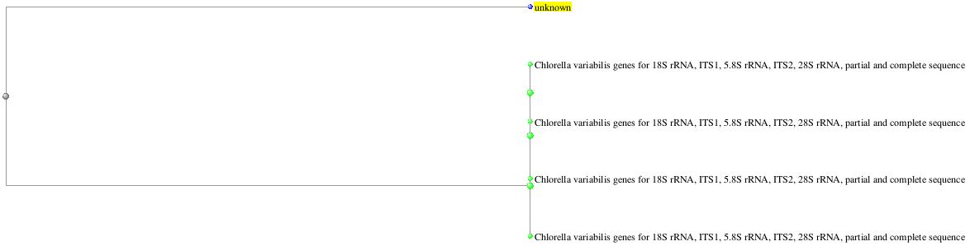

**Figure 1a**. **phylogenetic tree** **of *Chlorella vulgarisarif***

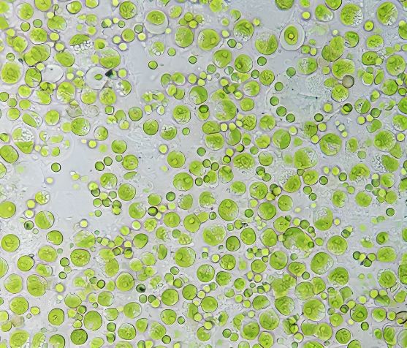

**Figure 1b. Microscopic view of *Chlorella vulgaris* (40X).**

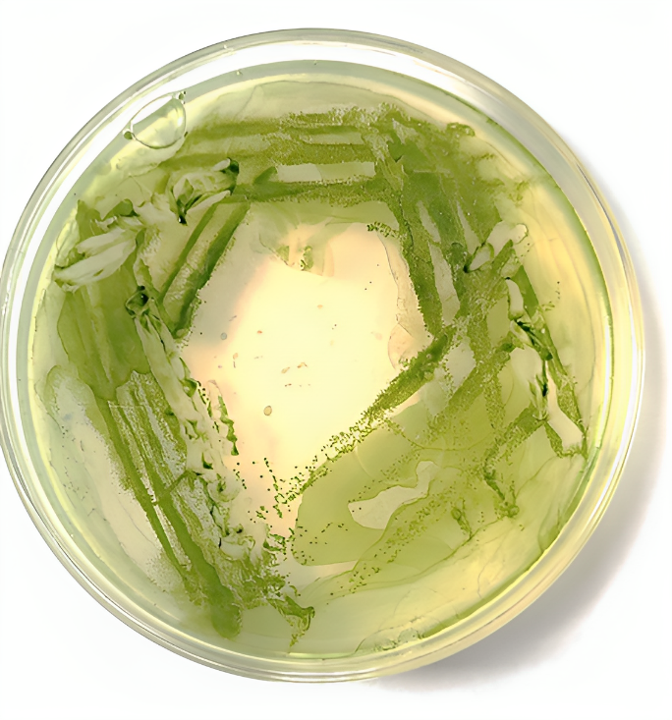

**Figure 1c. Culture plate of *Chlorella vulgaris.***

* **Optimization**

Khan et al., 2018 reported that the pH of the culture medium is another crucial element influencing microalgae development. The pH needs of various microalgae species vary. Most grow in the pH range of 5 to 8.67. The pH of many sources of growth medium varies., we grew the microalgal cells at a pH range of 4.5-7. the highest yield of biomass is obtained in the range of pH 5.5 to 6. In context to this, we performed the experiment, after 5 weeks of growth, the biomass production in several pH-altered culture bottles was assessed and pH 6 was shown to be the most favorable for growth. The weight of the dried algal biomass was determined using the gravimetric method and expressed in terms of gL-1 (Khan et al., 2018).

The biomass obtained is maximum at pH 6 (0.9±0.1 gL-1), followed by pH 5.5 (0.8 ± 0.1 gL-1) and 6.5 (0.7±0.1 gL-1), pH 5 (0.6±0.1 gL-1), pH 7 (0.5±0.1 gL-1), and the lowest biomass obtained in pH 4.5 (0.4±0.1.gL-1).

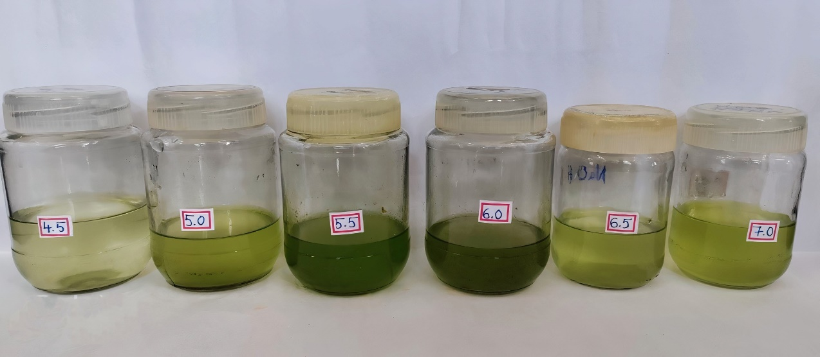

**F**

**D**

**C**

**B**

**E**

**A**

**Figure 2. Incubation of microalgae at different pH after 5 weeks**

**(A- 4.5, B-5.0, C-5.5, D-6.0, E-6.5, F-7.0)**

**Table 1. Microalgal biomass in different pH**

|  |  |
| --- | --- |
| **pH range** | **Biomass yield (gL-1)** |
| 4.5 | 0.4±0.1 |
| 5 | 0.6±0.1 |
| 5.5 | 0.8±0.1 |
| 6 | 0.9±0.1 |
| 6.5 | 0.7±0.1 |
| 7 | 0.5±0.1 |

**Graph 1. Growth curve of microalgae at different pH**

Chowdhury, et al., 2013 studied that temperature is regarded as one of the most important environmental elements influencing algal growth rate, cell size, metabolic makeup, and nutritional requirements. Microalgae cultures absorb heat from the light source employed, resulting in a rise in temperature in the culture. Thus, for a large-scale outdoor culture, the irradiation of sunshine and accompanying temperature must also be considered. The ideal temperature for microalgae development is between 20 and 350 Celsius, while certain mesophilic species may tolerate temperatures as high as 400 Celsius. The yield of the strain decreases below the ideal temperature while overheating of the cultures has been recognized as crucial since it might harm the cells. So we cultured microalgae at three different temperatures: 180C, 270C, and 400C, and we obtained the best growth at normal room temperature from 250C to 270C. The growth rate of microalgae was observed at various temperatures; the optimal growth was observed at a normal room temperature of 27±2°C, in contrast to low temperature (18±2)°C in the refrigerator and high temperature (40±2)°C in the incubator. Using the gravimetric method, the weight of the dried algal biomass was calculated and expressed in terms of gL-1. The maximum biomass obtained was 0.7±0.1 gL-1 at room temperature of 27 °C, and the lowest biomass was 0.3 ± 0.1 gL-1 at 18 °C and 0.2 ± 0.1 gL-1 at 40 °C. and we obtained the best growth at normal room temperature 250C to 270C (Chowdhury, et al., 2013)

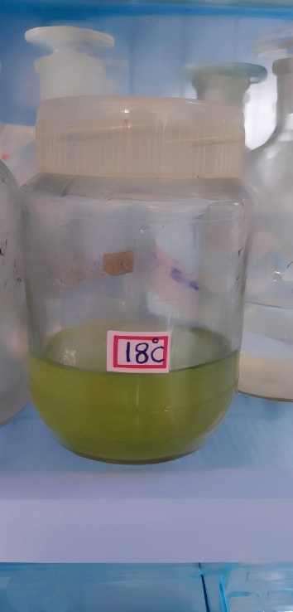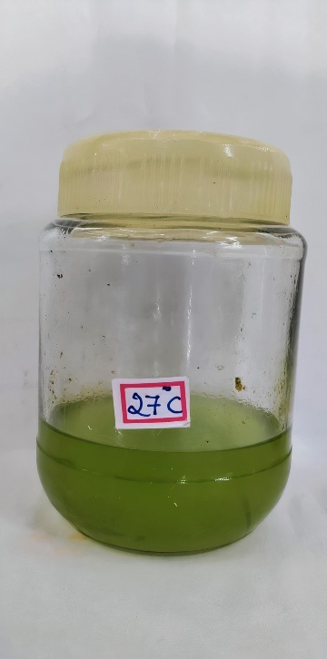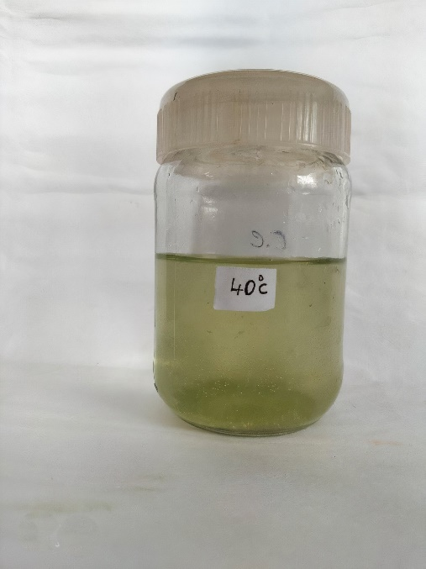

C

B

A

**Figure 3. The culture bottles in different Temperature after 5 weeks**

**(Temperature of A**-**18** **0 C, B**- **270 C, C**- **400 C)**

**Table 2. Microalgal biomass in different temperature**

|  |  |
| --- | --- |
| Temperature | Biomass yield (gL-1) |
| 18±2 | 0.3±0.1 |
| 27±2 | 0.7±0.1 |
| 40±2 | 0.2±0.1 |

**Graph 2. Growth curve of microalgae at different temperature**

**Carbon source**

The optimum growth of microalgae in different sources of carbon mixed into BG 11 media shows varying growth rates. When sodium carbonate (Na2CO3), bicarbonate (HCO3-), and organic carbon sources (acetate) are introduced into three separate culture bottles, the biomass production varies, with the media containing Na2CO3 yielding a higher yield of microalgae than the other two sources.

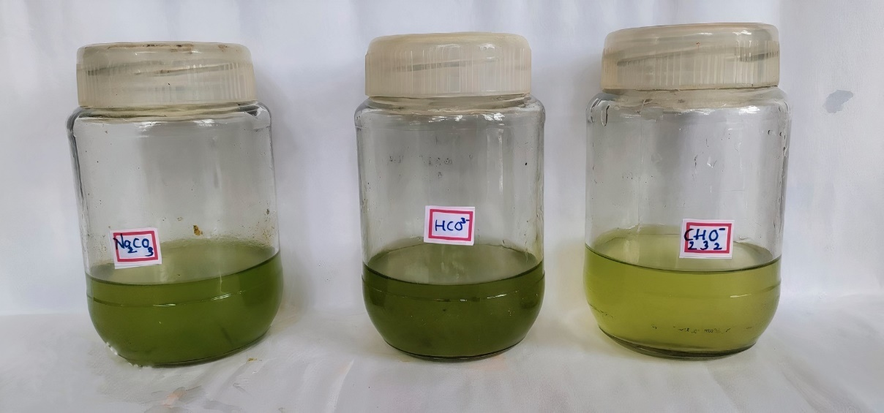

C

B

A

**Figure 4. The culture bottles with different carbon sources after 5 weeks**

**(Carbon source in A**-**Na2CO3, B**-**HCO3-, C-C2H3O**-2**)**

**Table 3. Microalgal biomass in different carbon sources**

|  |  |
| --- | --- |
| **Carbon sources** | **Biomass yield (gL-1)** |
| Na2CO3 | 0.76±0.2 |
| HCO3- | 0.63±0.2 |
| C2H3O2− | 0.45±0.2 |

**Graph 3. Growth curve of microalgae at different Carbon sources**

**Nitrogen source**

The optimal development of microalgae in different nitrogen sources incorporated into BG11 medium exhibits variable growth rates. When Sodium Nitrate (NaNO3), Ammonium Nitrate (NH4NO3), and urea are added to three distinct culture bottles, the biomass production varies, with the media containing NaNO3 giving a larger yield of microalgae than the other two sources.

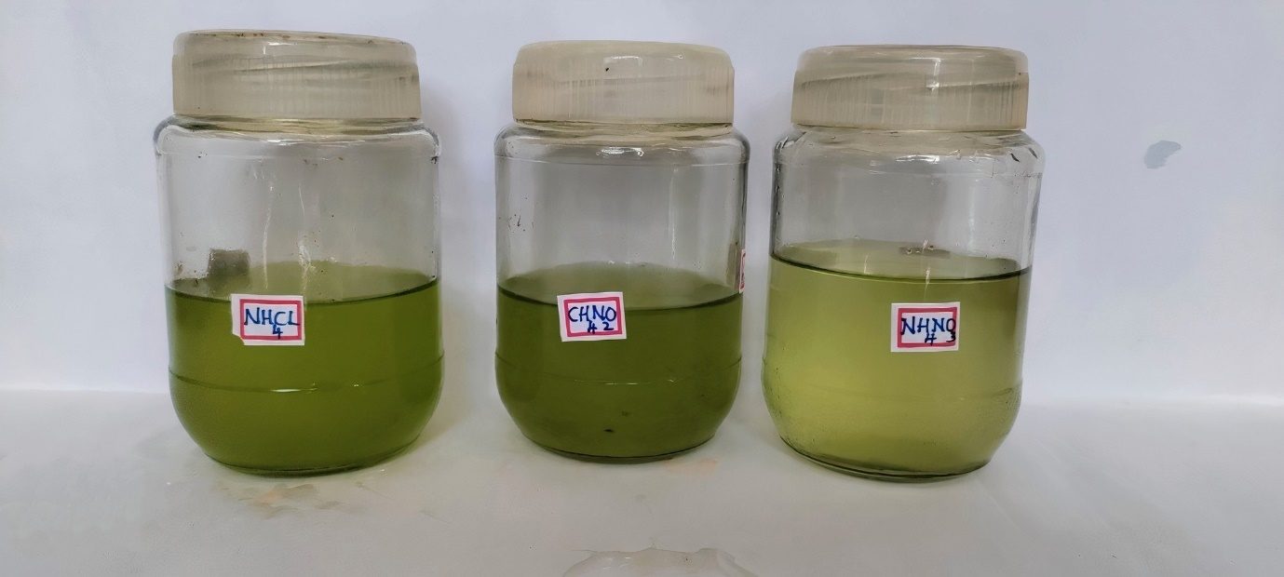

C

B

A

**Figure 5. The culture bottles with different nitrogen sources after 5 weeks**

**(Nitrogen source A**-**NH4Cl, B**-**NH4NO3, C**-**CH4N2O)**

**Table 4. Microalgal biomass in different Nitrogen sources**

|  |  |
| --- | --- |
| **Nitrogen sources** | **Biomass yield (gL-1)** |
| NH4Cl | 0.68 |
| NH4NO3 | 0.53 |
| CH4N2O | 0.60 |

**Graph 4. Growth curve of microalgae at different Nitrogen sources**

* **Lipid estimation**

Using the Bligh dyer method, the total lipid content of microalgal biomass has been determined.

By using the formula = lipid content in the vial (W2) - pre-weighed vial (W1)

lipid content in the vial = 23.299 g

weight if empty vial =23.239 g

(23.299-23.239) = 0.060 g (60mmol)

By transesterification the obtained lipid content in 1 gram is 60 mmol.

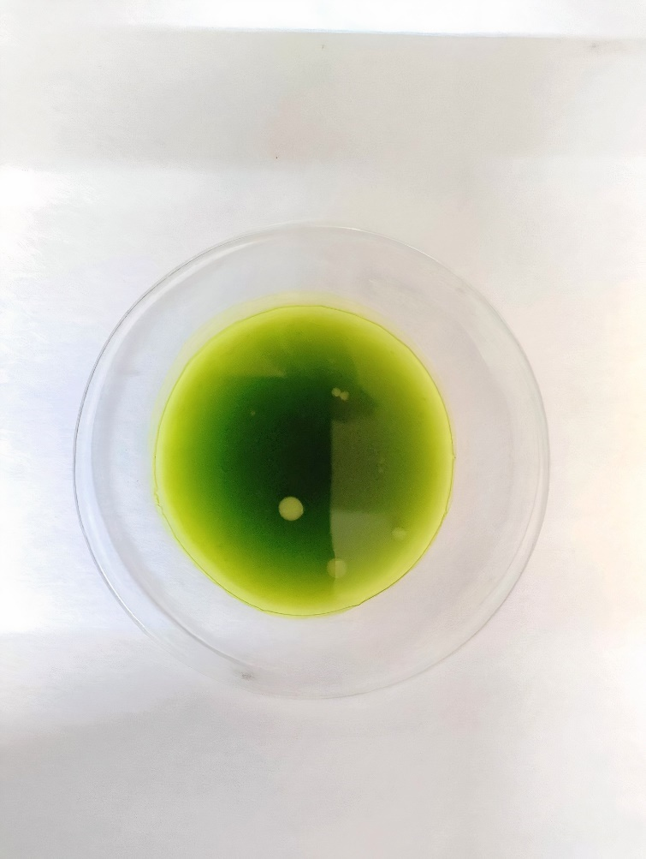 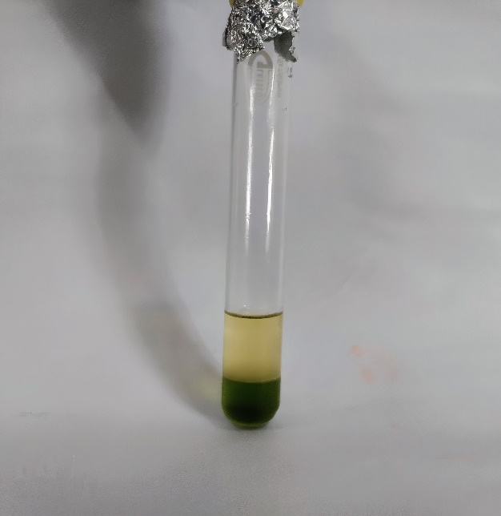

Biofuel

**Figure 6a. Extracted lipid Figure 6b. Test tube showing biofuel**

* **FTIR peak of Biofuel**

Vidyadharani, et al., 2013 got the result of FT-IR analysis for lipid samples of *Chlorella* was found to include amino, alcohol, aromatic, alkyne, alkene, acid, ether, and alkyl halide groups, according to the FT-IR transmittance spectrum. Because of the asymmetric C–H stretching vibration, the *Chlorella vulgaris* extract was discovered to have a weak band that was centered on 2920 cm–1. The bands that were seen at around 2669 cm–1 matched the symmetric stretching vibration of C–H in Chlorella vulgaris. The presence of acetic acid and its methyl ester derivatives was indicated by bands approaching the range of 3051 cm-1, whereas the C=C stretching pattern in Chlorella vulgaris was indicated by bands nearing 3334 cm-1, 1592.15, 1491.49, and 1437.55 cm-1. We found bands at 3200 cm-1 that corresponded to the symmetric O-H stretching vibration in Chlorella vulgaris. The presence of alkene was indicated by bands around 1500-1800 cm-1 and aromatic stretching was found in 2122cm-1. The following results were found by comparing the FTIR peak (Figure 6) with respect to wavelength and a standard chemical bond.

**Table 5. Expected compounds in Chlorella vulgaris strain FTIR absorption spectrum**

|  |  |  |
| --- | --- | --- |
| **S.No.** | **Frequency in wavelength**  **, in cm-1** | **Assignment of vibration** |
| **1.** | 3200-3400 | OH stretching vibration |
| **2.** | 1500-1800 | C=C stretching vibration |
| **3.** | 2122-2361 | Aromatic stretching vibration |
| **4.** | Below 600 | Alkyl stretching |

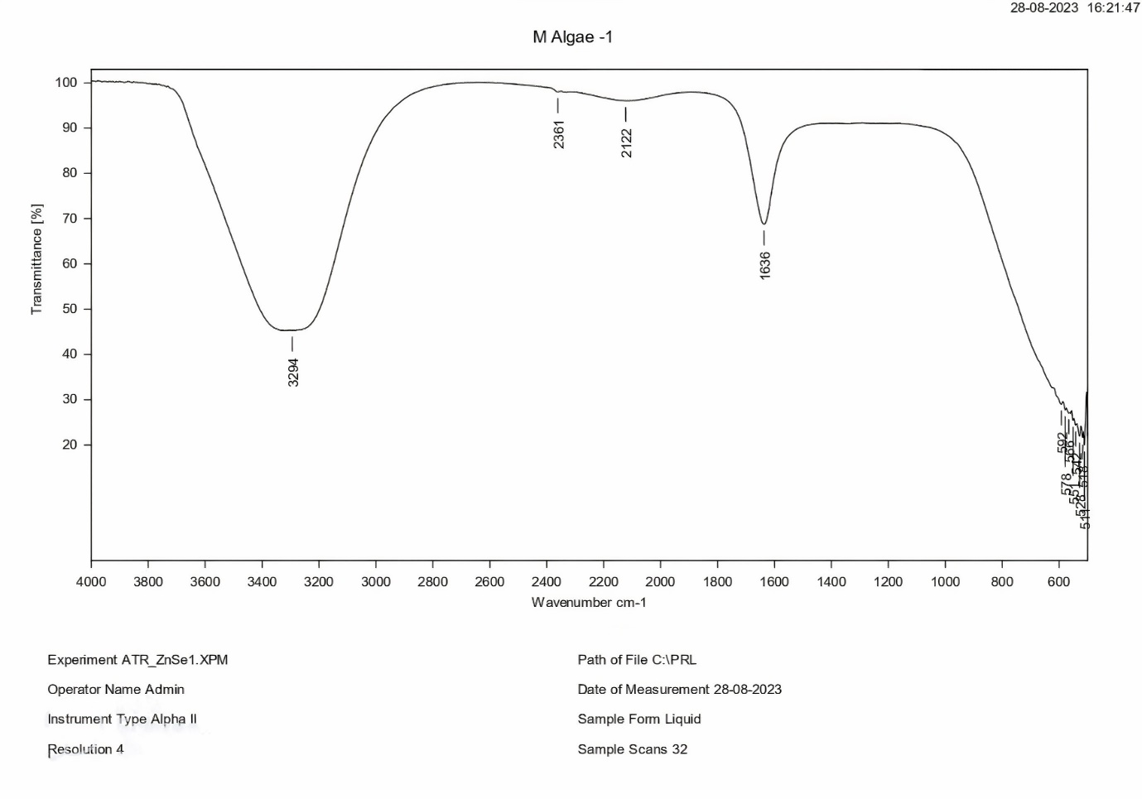**Graph 5. FTIR of Biofuel**.

The characteristic peaks on a biofuel spectrum are one at 3200-3400 cm-1 which is related to OH stretching vibrations. This shows that the peak characterized by OH vibrations is prominent in all the spectra. Furthermore, bands between 1500 and 1800 cm-1 are assigned to c=c stretching vibrations, while bands between 2122 and 2361 cm-1 are related to aromatic stretching vibrations. These findings support the study of (Villagracia et al., 2016) on biofuel derived from chlorella. The presence of methyl ester groups in the analysis verifies the purity of the corresponding biodiesel samples. We found bands at 3200 cm-1 that corresponded to the symmetric O-H stretching vibration in Chlorella vulgaris. The presence of alkene was indicated by bands around 1500-1800 cm-1 and aromatic stretching was found in 2122cm-1. (Vidyadharani, et al., 2013)

**5. CONCLUSION**

The microscopic form and wide diversity of the microalgae subgroup stand out as an important component of world ecosystems, serving as primary producers, contributing considerably to oxygen production, and presenting potential applications in biofuel production. The study of algae, particularly microalgae, in the context of biofuels, is a possible option for long-term energy production. our study mainly focused on the isolation of microalgae from lake water samples and optimization for optimal growth in different pH, Temperature, Carbon source, nitrogen source, and production of Biofuel from lipid transesterification.

By exploiting the inherent potential of microalgae, we can use it as valuable resources while reducing our reliance on fossil fuels. Adopting this growing technique has the potential to adopt the way for a greener, more sustainable future in which Agro-waste is considered a source of opportunity and growth rather than a problem. We can realize the full potential of microalgae-based biofuels through continued research, investment, and collaboration, paving the path for a greener and more prosperous future

**6. Reference**

* Protist taxonomy: an ecological perspective. *Philosophical Transactions of* Finlay, B. J. (2004) *the royal society of London. Series B: Biological sciences*, *359*(1444), 599-610.
* Osundeko, O. (2014). *Sustainable Production of Biofuel from Microalgae Grown in Wastewater*. The University of Manchester (United Kingdom).
* Not, F., Siano, R., Kooistra, W. H., Simon, N., Vaulot, D., & Probert, I. (2012). Diversity and ecology of eukaryotic marine phytoplankton. In *Advances in botanical research* (Vol. 64, pp. 1-53). Academic Press.
* Lembi, C. A., & Waaland, J. R. (Eds.). (1988). *Algae and human affairs*. Cambridge University Press.
* Delwiche, C. F., & Cooper, E. D. (2015). The evolutionary origin of a terrestrial flora. *Current Biology*, *25*(19), R899-R910.
* Rajak, U., Nashine, P., & Verma, T. N. (2019). Characteristics of microalgae spirulina biodiesel with the impact of n-butanol addition on a CI engine. Energy, 189, 116311.
* Humphrey, S. (2019). *Freshwater Microbiology*. Scientific e-Resources.
* Mimouni, V., Ulmann, L., Pasquet, V., Mathieu, M., Picot, L., Bougaran, G., ... & Schoefs, B. (2012). The potential of microalgae for the production of bioactive molecules of pharmaceutical interest. *Current pharmaceutical biotechnology*, *13*(15), 2733-2750.
* Abdul-hameed, H. F. (2011). *Production of Biodiesel from Algae* (Doctoral dissertation, University of Baghdad).
* Lee, S., & Shah, Y. T. (2012). *Biofuels and bioenergy: processes and technologies*. CRC Press.
* Nanda, S., Rana, R., Sarangi, P. K., Dalai, A. K., & Kozinski, J. A. (2018). A broad introduction to first-, second-, and third-generation biofuels. *Recent advancements in biofuels and bioenergy utilization*, 1-25.
* Naik, S. N., Goud, V. V., Rout, P. K., & Dalai, A. K. (2010). Production of first and second generation biofuels: a comprehensive review. *Renewable and sustainable energy reviews*, *14*(2), 578-597.
* Dragone, G., Fernandes, B. D., Vicente, A. A., & Teixeira, J. A. (2010). Third generation biofuels from microalgae.
* Ganesan, R., Manigandan, S., Samuel, M. S., Shanmuganathan, R., Brindhadevi, K., Chi, N. T. L., ... & Pugazhendhi, A. (2020). A review on prospective production of biofuel from microalgae. *Biotechnology Reports*, *27*, e00509.
* Hays, S. G., Yan, L. L., Silver, P. A., & Ducat, D. C. (2017). Synthetic photosynthetic consortia define interactions leading to robustness and photoproduction. *Journal of biological engineering*, *11*, 1-14.
* Chiranjeevi, P., & Mohan, S. V. (2016). Critical parametric influence on microalgae cultivation towards maximizing biomass growth with simultaneous lipid productivity. *Renewable Energy*, *98*, 64-71.
* Das, P., Aziz, S. S., & Obbard, J. P. (2011). Two phase microalgae growth in the open system for enhanced lipid productivity. *Renewable Energy*, *36*(9), 2524-2528.
* Singh, A. K., Sharma, N., Farooqi, H., Abdin, M. Z., Mock, T., & Kumar, S. (2017). Phycoremediation of municipal wastewater by microalgae to produce biofuel. *International journal of phytoremediation*, *19*(9), 805-812.
* Ramluckan, K., Moodley, K. G., & Bux, F. (2014). An evaluation of the efficacy of using selected solvents for the extraction of lipids from algal biomass by the soxhlet extraction method. *Fuel*, *116*, 103-108.
* Chouhan, A. S., & Sarma, A. K. (2011). Modern heterogeneous catalysts for biodiesel production: A comprehensive review. *Renewable and Sustainable Energy Reviews*, *15*(9), 4378-4399.
* Arif, M., Li, Y., El-Dalatony, M. M., Zhang, C., Li, X., & Salama, E. S. (2021). A complete characterization of microalgal biomass through FTIR/TGA/CHNS analysis: An approach for biofuel generation and nutrients removal. *Renewable Energy*, *163*, 1973-1982.
* Manjunatha, S. S., & Girisha, S. T. (2019). Isolation and Screening of Chlorella Sorokiniana for Wastewater Treatment and Biodiesel Production. *International Journal of Scientific Research in Biological Sciences*, *6*(2), 59-67.
* Khan, M. I., Shin, J. H., & Kim, J. D. (2018). The promising future of microalgae: current status, challenges, and optimization of a sustainable and renewable industry for biofuels, feed, and other products. Microbial cell factories, 17(1), 1-21.
* Voloshin, R. A., Rodionova, M. V., Zharmukhamedov, S. K., Veziroglu, T. N., & Allakhverdiev, S. I. (2016). Biofuel production from plant and algal biomass. *International journal of hydrogen energy*, *41*(39), 17257-17273.
* Mata, T. M., Martins, A. A., & Caetano, N. S. (2010). Microalgae for biodiesel production and other applications: a review. *Renewable and sustainable energy reviews*, *14*(1), 217-232.
* Vidyadharani, G., & Dhandapani, R. (2013). Fourier transform infrared (FTIR) spectroscopy for the analysis of lipid from Chlorella vulgaris. Elixir Appl. Biol, 61, 16753-16756.
* Li, Y., Horsman, M., Wu, N., Lan, C. Q., & Dubois‐Calero, N. (2008). Biofuels from microalgae. *Biotechnology progress*, *24*(4), 815-820.
* Rodolfi, L., Chini Zittelli, G., Bassi, N., Padovani, G., Biondi, N., Bonini, G., & Tredici, M. R. (2009). Microalgae for oil: Strain selection, induction of lipid synthesis and outdoor mass cultivation in a low‐cost photobioreactor. *Biotechnology and bioengineering*, *102*(1), 100-112.
* Lv, J. M., Cheng, L. H., Xu, X. H., Zhang, L., & Chen, H. L. (2010). Enhanced lipid production of Chlorella vulgaris by adjustment of cultivation conditions. *Bioresource technology*, *101*(17), 6797-6804.
* Barbosa, M. J., Albrecht, M., & Wijffels, R. H. (2003). Hydrodynamic stress and lethal events in sparged microalgae cultures. *Biotechnology and bioengineering*, *83*(1), 112-120.
* Ranjith Kumar, R., Hanumantha Rao, P., & Arumugam, M. (2015). Lipid extraction methods from microalgae: a comprehensive review. *Frontiers in Energy Research*, *2*, 61.
* de Jesus, S. S., Ferreira, G. F., Moreira, L. S., Maciel, M. R. W., & Maciel Filho, R. (2019). Comparison of several methods for effective lipid extraction from wet microalgae using green solvents. *Renewable Energy*, *143*, 130-141.
* Avhad, M. R., & Marchetti, J. M. (2016). Innovation in solid heterogeneous catalysis for the generation of economically viable and ecofriendly biodiesel: A review. *Catalysis Reviews*, *58*(2), 157-208.
* Villagracia, A. R. C., Mayol, A. P., Ubando, A. T., Biona, J. B. M. M., Arboleda, N. B., David, M. Y., ... & Kasai, H. (2016). Microwave drying characteristics of microalgae (Chlorella vulgaris) for biofuel production. *Clean technologies and environmental policy*, *18*, 2441-2451.
* Ji, F., Liu, Y., Hao, R., Li, G., Zhou, Y., & Dong, R. (2014). Biomass production and nutrients removal by a new microalgae strain Desmodesmus sp. in anaerobic digestion wastewater. Bioresource technology, 161, 200-207.
* Zhu, F., Massana, R., Not, F., Marie, D., & Vaulot, D. (2005). Mapping of picoeucaryotes in marine ecosystems with quantitative PCR of the 18S rRNA gene. FEMS microbiology ecology, 52(1), 79-92.
* Gupta, V., Ratha, S. K., Sood, A., Chaudhary, V., & Prasanna, R. (2013). New insights into the biodiversity and applications of cyanobacteria (blue-green algae)—Prospects and challenges. Algal research, 2(2), 79-97.